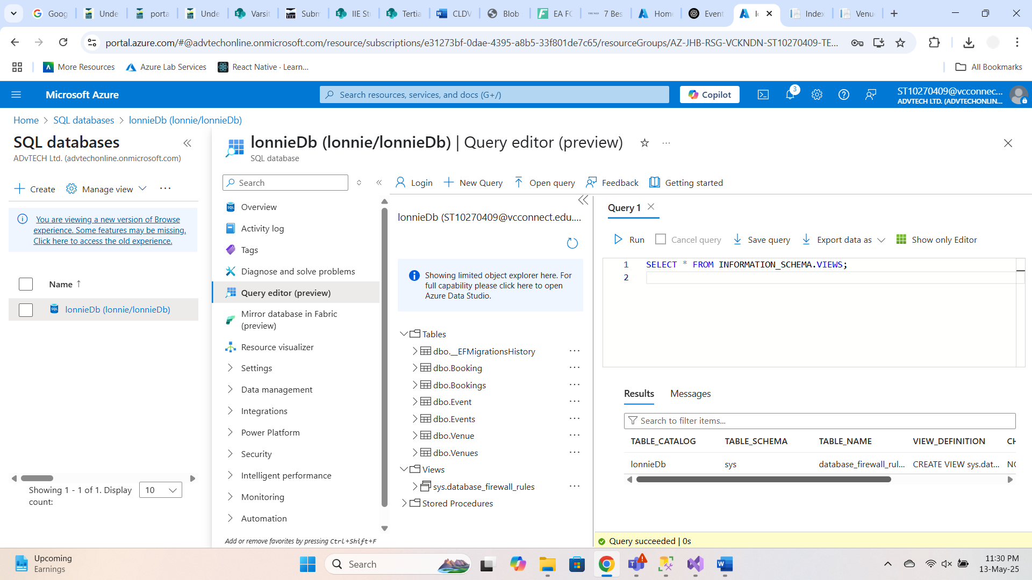

<https://lonniedb20250407201714.azurewebsites.net/Venue>

**Azure Cognitive Search vs Traditional Search Engines**

**Azure Cognitive Search** is a cloud-based AI-powered search-as-a-service offering by Microsoft. Unlike traditional search engines (like Elasticsearch or Lucene), which primarily rely on full-text indexing and keyword matches, Cognitive Search integrates **AI enrichment capabilities**, enabling **semantic understanding**, **OCR**, **image analysis**, **language detection**, and **natural language processing (NLP)**.

**Key Differences:**

|  |  |  |
| --- | --- | --- |
| **Feature** | **Azure Cognitive Search** | **Traditional Search Engine** |
| AI Enrichment | Yes – OCR, NLP, sentiment analysis, etc. | No or requires manual integration |
| Built-in Indexers | Azure SQL, Blob, Cosmos DB | Manual setup required |
| Integration with Azure ecosystem | Native | Third-party plugins/tools |
| Skillsets/Knowledge mining | Available (e.g. extract key phrases from docs) | Not built-in |

**Use Cases Where Cognitive Search Excels:**

* Searching across scanned documents (e.g. PDFs/images using OCR)
* Extracting knowledge from unstructured customer feedback
* Enabling intelligent search in e-commerce platforms
* Legal and medical document indexing and discovery

**Example:** In an event booking system like *EventEase*, Cognitive Search could index **event titles, descriptions, and venue names**, and allow users to search for “music events in Cape Town this weekend” using natural language.

**Limitations & Mitigations:**

| **Limitation** | **Mitigation** |
| --- | --- |
| Cost for large-scale use | Use free tier or optimize indexing schedules |
| Complexity of AI enrichment setup | Use built-in skills and templates |
| Limited language support in some areas | Custom skillsets or integrate external NLP tools |
| Not as customizable as Elasticsearch | Use Azure OpenAI or build hybrid models |

*Azure Cognitive Search is ideal for intelligent enterprise search scenarios but may require tuning and cost management for large-scale data processing.*

**Reference:**  
Microsoft. (2023) *What is Azure Cognitive Search?* [Online] Available at: <https://learn.microsoft.com/en-us/azure/search/search-what-is-azure-search>

**Importance of Database Normalisation in Cloud-Based Design**

**Database normalisation** is the process of structuring a database to reduce redundancy and improve data integrity. In cloud environments like **Azure SQL Database**, proper normalisation is essential for performance, security, and scalability.

**Why Normalisation Matters:**

* **Reduces data duplication**, saving storage and bandwidth costs.
* **Improves consistency**, reducing errors from update anomalies.
* **Enhances query reliability** by enforcing relationships through foreign keys.
* **Supports modular scaling** by splitting data across services or shards.

In a normalised schema for EventEase:

* Venue table stores venue info
* Event table links to Venue via foreign key
* Booking table links to both Event and Venue

**Normalized vs Denormalized in Azure:**

|  |  |  |
| --- | --- | --- |
| **Factor** | **Normalized** | **Denormalized** |
| Storage | Efficient (less duplication) | Uses more space |
| Query Complexity | Higher (joins required) | Simpler queries (flat structures) |
| Performance | Good for OLTP (frequent updates) | Good for OLAP (reporting/analytics) |
| Scalability | Easier to partition by entity | Scales well with read-heavy loads |

**Cloud Impact:**

* In Azure, **normalized design** is preferred for transactional apps like bookings.
* **Denormalized design** (like materialized views) is ideal for dashboards or reporting where performance > integrity.
* Hybrid approaches (e.g. read-optimized views) can balance both needs.

Normalisation ensures long-term **scalability and maintainability**, especially in multi-tenant or distributed architectures common in cloud-native applications.

**Reference:**  
Elmasri, R. & Navathe, S. (2017) *Fundamentals of Database Systems.* 7th ed. Boston: Pearson.  
Microsoft. (2023) *Azure SQL Database design guidance.* [Online] Available at: <https://learn.microsoft.com/en-us/azure/azure-sql/database/design-best-practices>